R project
Makeila Sandoval
2026-05-06

=========================================

WORLD HAPPINESS REPORT 2020 ANALYSIS 🤍

=========================================
Objectives Analyze global happiness scores Identify relationships between happiness and economic/social indicators Compare high- and low-happiness countries Visualize trends using ggplot2
library(tidyverse)
## ── Attaching core tidyverse packages ──────────────────────── tidyverse 2.0.0 ──
## ✔ dplyr 1.2.1 ✔ readr 2.2.0
## ✔ forcats 1.0.1 ✔ stringr 1.6.0
## ✔ ggplot2 4.0.3 ✔ tibble 3.3.1
## ✔ lubridate 1.9.5 ✔ tidyr 1.3.2
## ✔ purrr 1.2.2
## ── Conflicts ────────────────────────────────────────── tidyverse_conflicts() ──
## ✖ dplyr::filter() masks stats::filter()
## ✖ dplyr::lag() masks stats::lag()
## ℹ Use the conflicted package (<http://conflicted.r-lib.org/>) to force all conflicts to become errors
library(dplyr)
happiness <- read.csv("2020.csv")
head(happiness)
## Country.name Happiness.Rank Happiness.score Upperwhisker Lowerwhisker
## 1 Finland 1 7.81 7.87 7.75
## 2 Denmark 2 7.65 7.71 7.58
## 3 Switzerland 3 7.56 7.63 7.49
## 4 Iceland 4 7.50 7.62 7.39
## 5 Norway 5 7.49 7.56 7.42
## 6 Netherlands 6 7.45 7.50 7.39
## Economy..GDP.per.Capita.. Social.support Healthy.life.expectancy
## 1 1.29 1.50 0.96
## 2 1.33 1.50 0.98
## 3 1.39 1.47 1.04
## 4 1.33 1.55 1.00
## 5 1.42 1.50 1.01
## 6 1.34 1.46 0.98
## Freedom.to.make.life.choices Generosity Perceptions.of.corruption
## 1 0.66 0.16 0.48
## 2 0.67 0.24 0.50
## 3 0.63 0.27 0.41
## 4 0.66 0.36 0.14
## 5 0.67 0.29 0.43
## 6 0.61 0.34 0.37
library(dplyr)
happiness <- happiness %>%
rename(
country = Country.name,
rank = Happiness.Rank,
score = Happiness.score,
upper_whisker = Upperwhisker,
lower_whisker = Lowerwhisker,
gdp_per_capita = Economy..GDP.per.Capita..,
social_support = Social.support,
life_expectancy = Healthy.life.expectancy,
freedom = Freedom.to.make.life.choices,
generosity = Generosity,
corruption = Perceptions.of.corruption,
)

=========================================

DATA CLEANING 🤍

=========================================
Renaming variables for readability Removing missing values Removing duplicate rows Checking data structure and variable types
colSums(is.na(happiness))
## country rank score upper_whisker lower_whisker
## 0 0 0 0 0
## gdp_per_capita social_support life_expectancy freedom generosity
## 0 0 0 0 0
## corruption
## 0
happiness <- na.omit(happiness)
happiness <- distinct(happiness)
str(happiness)
## 'data.frame': 153 obs. of 11 variables:
## $ country : chr "Finland" "Denmark" "Switzerland" "Iceland" ...
## $ rank : int 1 2 3 4 5 6 7 8 9 10 ...
## $ score : num 7.81 7.65 7.56 7.5 7.49 7.45 7.35 7.3 7.29 7.24 ...
## $ upper_whisker : num 7.87 7.71 7.63 7.62 7.56 7.5 7.42 7.38 7.36 7.3 ...
## $ lower_whisker : num 7.75 7.58 7.49 7.39 7.42 7.39 7.28 7.22 7.23 7.18 ...
## $ gdp_per_capita : num 1.29 1.33 1.39 1.33 1.42 1.34 1.32 1.24 1.32 1.54 ...
## $ social_support : num 1.5 1.5 1.47 1.55 1.5 1.46 1.43 1.49 1.44 1.39 ...
## $ life_expectancy: num 0.96 0.98 1.04 1 1.01 0.98 0.99 1.01 1 0.99 ...
## $ freedom : num 0.66 0.67 0.63 0.66 0.67 0.61 0.65 0.65 0.6 0.61 ...
## $ generosity : num 0.16 0.24 0.27 0.36 0.29 0.34 0.27 0.33 0.26 0.2 ...
## $ corruption : num 0.48 0.5 0.41 0.14 0.43 0.37 0.44 0.46 0.28 0.37 ...

=========================================

DATA MANIPULATION WITH DPLYR 🤍

=========================================

Filter countries with high happiness score
high_happiness <- happiness %>% filter(score > 7)
This step filtered the dataset to identify countries with exceptionally high happiness scores.
Most countries with happiness scores above 7 were economically developed nations with high levels of social support and life expectancy.

Countries by happiness score
library(dplyr)
library(ggplot2)
top10 <- happiness %>%
arrange(desc(score)) %>%
slice(1:10)
ggplot(top10, aes(x = reorder(country, score), y = score)) +
geom_col(fill = "steelblue") +
coord_flip() +
labs(
title = "Top 10 Happiest Countries",
x = "Country",
y = "Happiness Score") + theme_minimal()
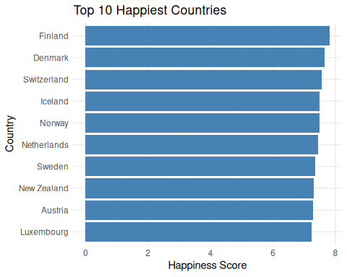
The visualization shows that Nordic countries such as Finland, Denmark, and Iceland ranked among the happiest countries in the world in 2020. These countries consistently scored highly in GDP per capita, social support, freedom, and healthy life expectancy.
bottom10 <- happiness %>% arrange(score) %>% slice(1:10)
ggplot(bottom10, aes(x = reorder(country, score), y = score)) +
geom_col(fill = "tomato") + coord_flip() +labs(
title = "Bottom 10 Happiest Countries",
x = "Country",
y = "Happiness Score") + theme_minimal()
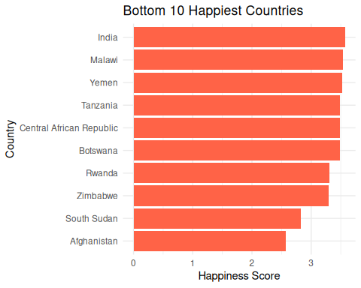
Many lower-ranked countries also showed lower GDP per capital and reduced social support, indicating a potential relationship between economic/social conditions and happiness.

Grouped summaries
happiness <- happiness %>%
mutate(level = case_when(score >= 7 ~ "High",
score >= 5 ~ "Medium",
TRUE ~ "Low"
)
)
Countries were grouped into three happiness categories: High, Medium, and Low. This categorization simplified comparisons between countries
summary_by_happiness <- happiness %>%
group_by(level) %>%
summarise(
Average_Happiness = mean(score),
Average_GDP = mean(gdp_per_capita),
Average_Social_Support = mean(social_support),
Average_Life_Expectancy = mean(life_expectancy),
Country_Count = n()
)
print(summary_by_happiness)
## # A tibble: 3 × 6
## level Average_Happiness Average_GDP Average_Social_Support
## <chr> <dbl> <dbl> <dbl>
## 1 High 7.33 1.32 1.45
## 2 Low 4.27 0.525 0.895
## 3 Medium 5.86 0.997 1.26
## # ℹ 2 more variables: Average_Life_Expectancy <dbl>, Country_Count <int>
The grouped summary revealed clear differences between happiness levels. GDP
High-happiness countries reported an average GDP per capita more than twice as large as low-happiness countries, suggesting a strong connection between economic prosperity and well-being.
Social Support
Social support levels were significantly higher among happier countries, indicating that strong social networks and community support may contribute positively to national happiness.
Life Expectancy
Countries with higher happiness scores also tended to have longer healthy life expectancy, suggesting that healthcare and quality of life are important contributors to happiness.

=========================================

DESCRIPTIVE STATISTICS 🤍

=========================================
summary(happiness)
## country rank score upper_whisker
## Length:153 Min. : 1 Min. :2.570 Min. :2.630
## Class :character 1st Qu.: 39 1st Qu.:4.720 1st Qu.:4.830
## Mode :character Median : 77 Median :5.510 Median :5.610
## Mean : 77 Mean :5.473 Mean :5.578
## 3rd Qu.:115 3rd Qu.:6.230 3rd Qu.:6.360
## Max. :153 Max. :7.810 Max. :7.870
## lower_whisker gdp_per_capita social_support life_expectancy
## Min. :2.510 Min. :0.0000 Min. :0.000 Min. :0.0000
## 1st Qu.:4.600 1st Qu.:0.5800 1st Qu.:0.990 1st Qu.:0.5000
## Median :5.430 Median :0.9200 Median :1.200 Median :0.7600
## Mean :5.368 Mean :0.8689 Mean :1.155 Mean :0.6931
## 3rd Qu.:6.140 3rd Qu.:1.1700 3rd Qu.:1.390 3rd Qu.:0.8700
## Max. :7.750 Max. :1.5400 Max. :1.550 Max. :1.1400
## freedom generosity corruption level
## Min. :0.0000 Min. :0.0000 Min. :0.0000 Length:153
## 1st Qu.:0.3800 1st Qu.:0.1200 1st Qu.:0.0600 Class :character
## Median :0.4800 Median :0.1800 Median :0.1000 Mode :character
## Mean :0.4635 Mean :0.1895 Mean :0.1306
## 3rd Qu.:0.5800 3rd Qu.:0.2600 3rd Qu.:0.1600
## Max. :0.6900 Max. :0.5700 Max. :0.5300
library(corrplot)
## corrplot 0.95 loaded
library(dplyr)
numeric_data <- happiness %>%
select(
score,
gdp_per_capita,
social_support,
life_expectancy,
freedom,
generosity,
corruption
)
corr_matrix <- cor(numeric_data, use = "complete.obs")
library(corrplot)
corrplot(
corr_matrix,
method = "color",
type = "upper",
order = "hclust",
addCoef.col = "black",
tl.col = "black",
tl.srt = 9,
tl.cex = 0.6,
col = colorRampPalette(c("blue", "white", "red"))(200)
)
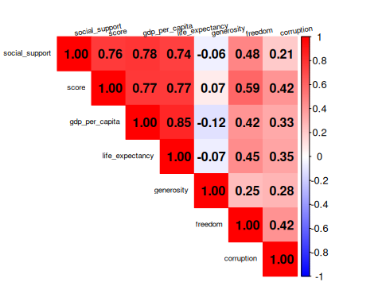
- GDP and Happiness
GDP per capita showed a strong positive correlation with happiness score (r = 0.77), suggesting that countries with stronger economies tend to report higher levels of happiness.
- Social Support Matters
Social support also had a strong relationship with happiness (r = 0.76), indicating that countries with stronger support systems generally report higher happiness scores.
- Life Expectancy
Healthy life expectancy was strongly associated with happiness levels (r = 0.77).
- Generosity Had Weak Correlation
Generosity showed only a weak relationship with happiness (r = 0.07).
## Variable Correlation
## 1 GDP per Capita 0.77452680
## 2 Social Support 0.76488666
## 3 Healthy Life Expectancy 0.76969468
## 4 Freedom of Choice 0.59089300
## 5 Generosity 0.07176264
## 6 Perception of Corruption 0.41847864

=========================================

Hypothesis Test 🤍

=========================================
t.test(
happiness$gdp_per_capita[happiness$level == "High"],
happiness$gdp_per_capita[happiness$level == "Low"]
)
##
## Welch Two Sample t-test
##
## data: happiness$gdp_per_capita[happiness$level == "High"] and happiness$gdp_per_capita[happiness$level == "Low"]
## t = 16.151, df = 64.594, p-value < 2.2e-16
## alternative hypothesis: true difference in means is not equal to 0
## 95 percent confidence interval:
## 0.6921432 0.8875016
## sample estimates:
## mean of x mean of y
## 1.3152941 0.5254717
Results:
p-value < 2.2e-16 Significant difference in GDP levels between groups
This suggests that higher GDP per capita is strongly associated with higher happiness scores.

=========================================

VISUALIZATIONS 🤍

=========================================
library(tidyr)
happiness_long <- happiness %>%
select(score,
gdp_per_capita,
social_support,
life_expectancy,
freedom,
generosity,
corruption) %>%
pivot_longer(
cols = -score,
names_to = "indicator",
values_to = "value"
)
ggplot(happiness_long, aes(x = value, y = score)) +
geom_point(alpha = 0.6, color = "steelblue") +
geom_smooth(method = "lm", se = FALSE, color = "red") +
facet_wrap(~ indicator, scales = "free_x") +
labs(
title = "Drivers of World Happiness",
x = "Indicator Value",
y = "Happiness Score"
) +
theme_minimal()
## `geom_smooth()` using formula = 'y ~ x'
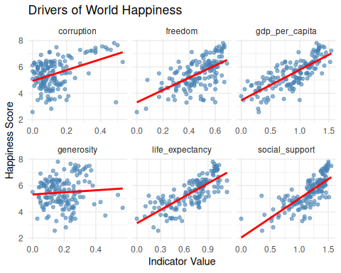

=========================================

End of Project 🤍

=========================================
The analysis suggests that economic stability, social support, and life expectancy are major contributors to national happiness levels. While freedom and corruption showed moderate relationships, generosity appeared to have minimal impact on overall happiness scores.

